DAY 4 – SELENIUM

D4E1:

package day4;

import org.openqa.selenium.WebDriver;

import org.openqa.selenium.chrome.ChromeDriver;

import org.openqa.selenium.chrome.ChromeOptions;

import io.github.bonigarcia.wdm.WebDriverManager;

public class D4E1 {

public static void main(String[] args)

{

WebDriverManager.chromedriver().setup();

ChromeOptions co = new ChromeOptions();

co.addArguments("--remote-allow-origins=*");

WebDriver driver = new ChromeDriver(co);

driver.get("https://demo.opencart.com/index.php?route=account/register&language=en-gb");

}

}

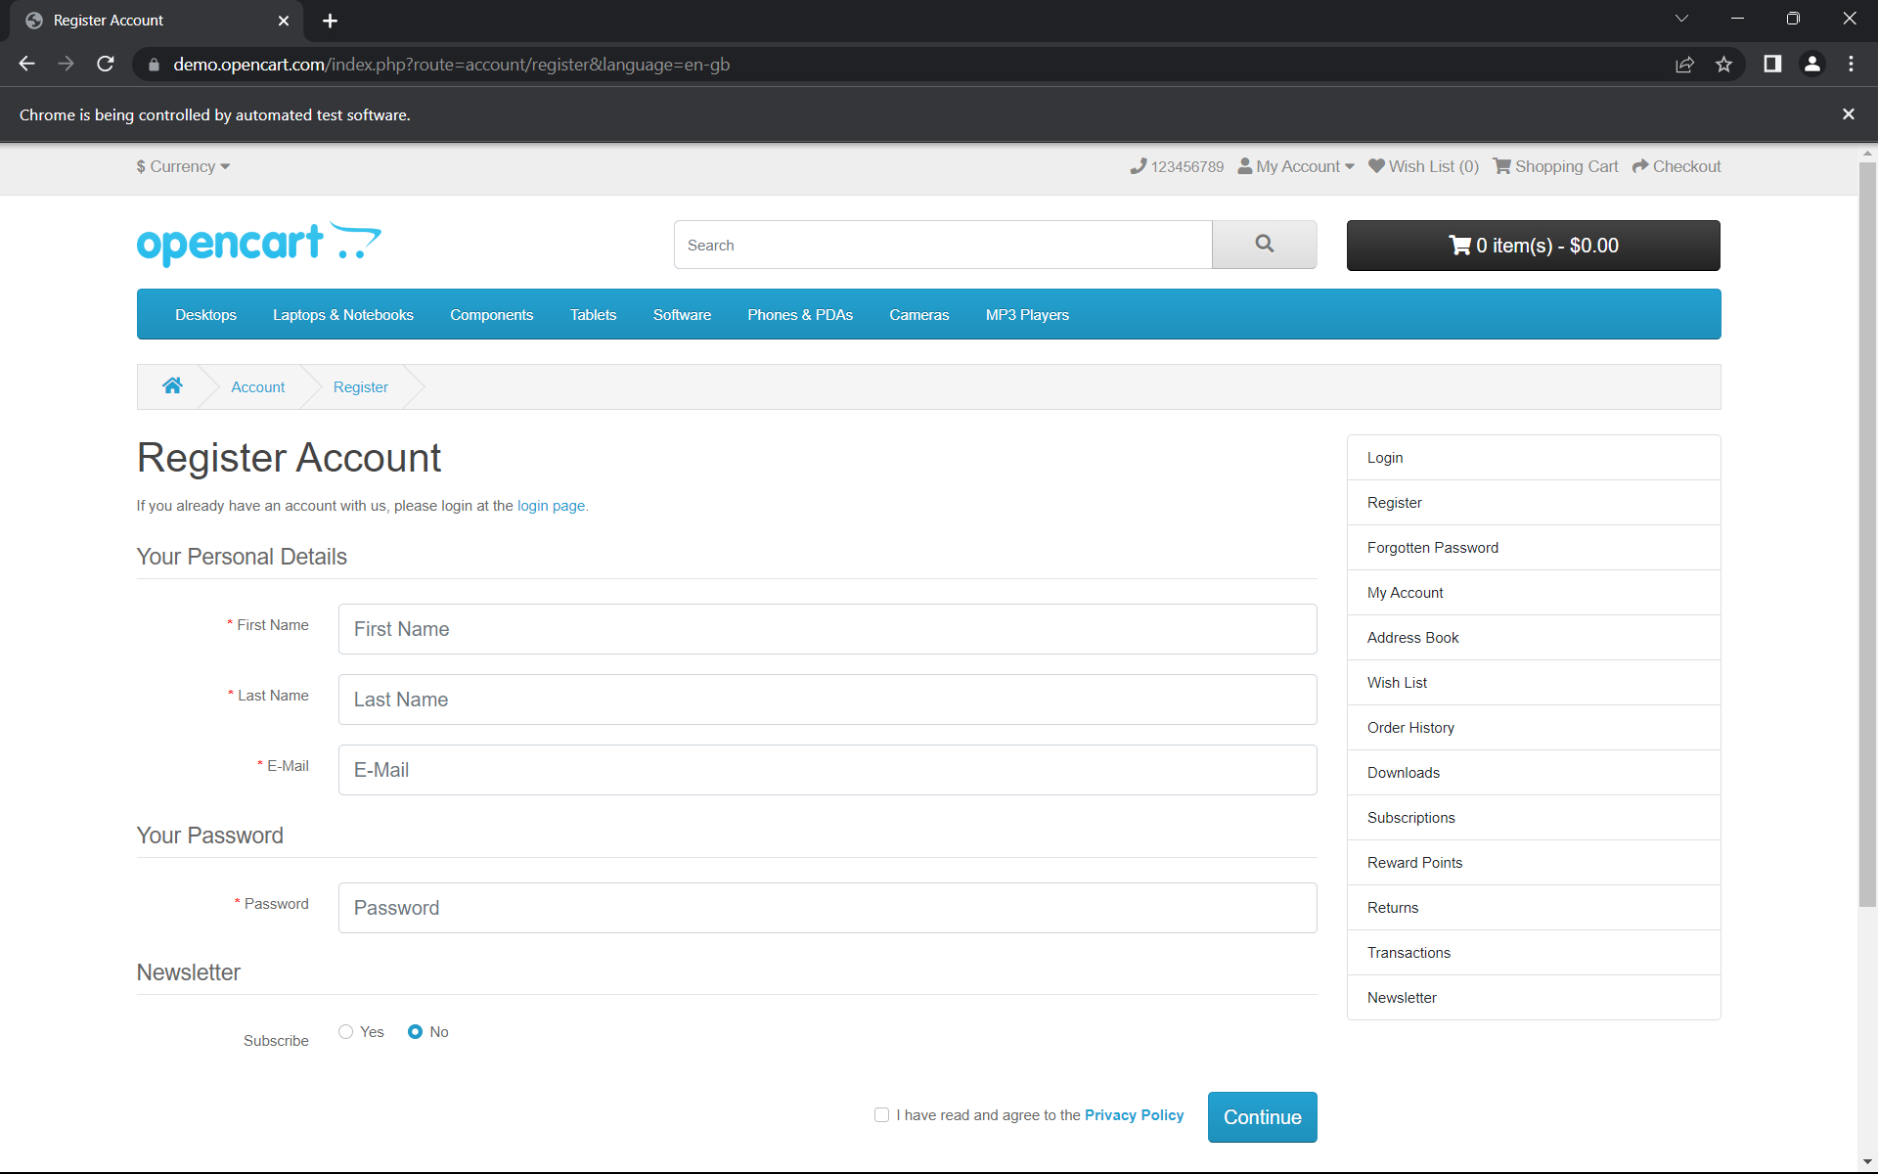

D4E2:

package D4;

import org.openqa.selenium.By;

import org.openqa.selenium.JavascriptExecutor;

import org.openqa.selenium.WebDriver;

import org.openqa.selenium.WebElement;

import org.openqa.selenium.chrome.ChromeDriver;

import org.openqa.selenium.chrome.ChromeOptions;

public class D4E2 {

public static void main(String[] args) throws InterruptedException {

System.setProperty("webdriver.chrome.driver","C:\\ChromeDriver\\chromedriver.exe");

ChromeOptions co = new ChromeOptions();

co.addArguments("--remote-allow-origins=*");

WebDriver driver = new ChromeDriver(co);

driver.get("https://demo.opencart.com/index.php?route=account/register&language=en-gb");

WebElement fname = driver.findElement(By.id("input-firstname"));

fname.sendKeys("Kaviya");

WebElement lname = driver.findElement(By.id("input-lastname"));

lname.sendKeys("Govindaraj");

WebElement email = driver.findElement(By.id("input-email"));

email.sendKeys("kaviya@gmail.com");

WebElement password = driver.findElement(By.id("input-password"));

password.sendKeys("Kaviya");

JavascriptExecutor js=(JavascriptExecutor)driver;

js.executeScript("window.scrollBy(0,250)","");

Thread.sleep(3000);

WebElement subscribe = driver.findElement(By.id("input-newsletter-yes"));

subscribe.click();

}

}

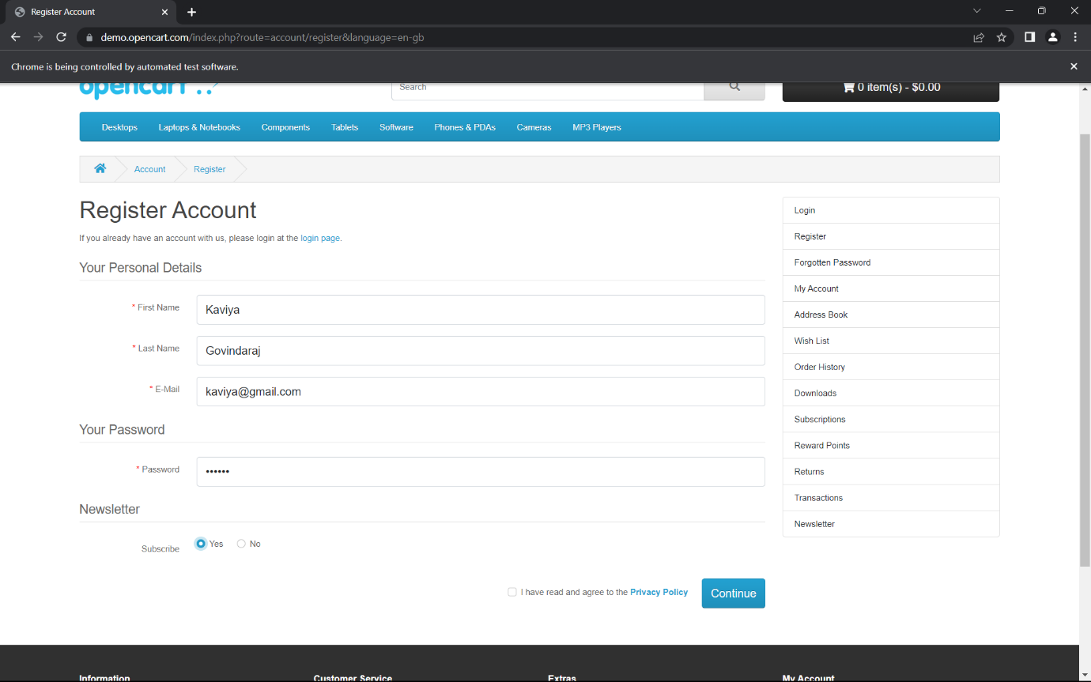

D4E3:

package D4;

import org.openqa.selenium.By;

import org.openqa.selenium.JavascriptExecutor;

import org.openqa.selenium.WebDriver;

import org.openqa.selenium.WebElement;

import org.openqa.selenium.chrome.ChromeDriver;

import org.openqa.selenium.chrome.ChromeOptions;

public class D4E3 {

public static void main(String[] args) throws InterruptedException {

System.setProperty("webdriver.chrome.driver","C:\\ChromeDriver\\chromedriver.exe");

ChromeOptions co = new ChromeOptions();

co.addArguments("--remote-allow-origins=*");

WebDriver driver = new ChromeDriver(co);

driver.get("https://demo.opencart.com/index.php?route=checkout/voucher&language=en-gb");

WebElement rname = driver.findElement(By.xpath("//*[@id=\"input-to-name\"]"));

rname.sendKeys("Kaviya Govindaraj");

WebElement remail = driver.findElement(By.xpath("//*[@id=\"input-to-email\"]"));

remail.sendKeys("KaviyaGovindaraj@gmail.com");

WebElement name = driver.findElement(By.xpath("//*[@id=\"input-from-name\"]"));

name.sendKeys("Kaviya");

WebElement email = driver.findElement(By.xpath("//*[@id=\"input-from-email\"]"));

email.sendKeys("Kaviya@gmail.com");

WebElement gift = driver.findElement(By.xpath("//*[@id=\"input-theme-7\"]"));

gift.click();

WebElement msg = driver.findElement(By.xpath("//*[@id=\"input-message\"]"));

msg.sendKeys("Hello!!!");

JavascriptExecutor js=(JavascriptExecutor)driver;

js.executeScript("window.scrollBy(0,250)","");

Thread.sleep(3000);

WebElement amount = driver.findElement(By.xpath("//*[@id=\"input-amount\"]"));

amount.clear();

amount.sendKeys("5");

WebElement check = driver.findElement(By.xpath("//*[@id=\"form-voucher\"]/div[8]/div/div/input"));

check.click();

WebElement btn = driver.findElement(By.xpath("//*[@id=\"form-voucher\"]/div[8]/div/button"));

btn.click();

}

}

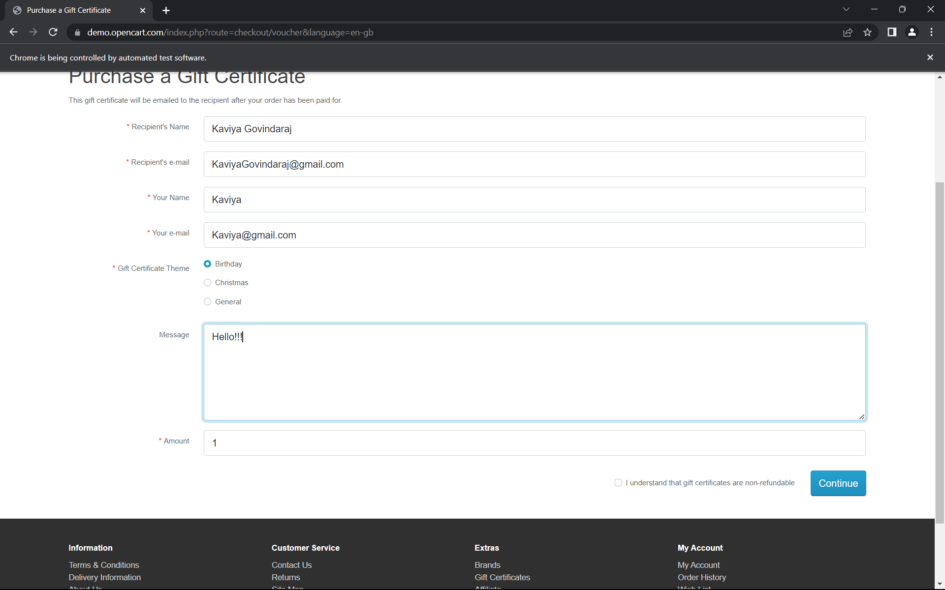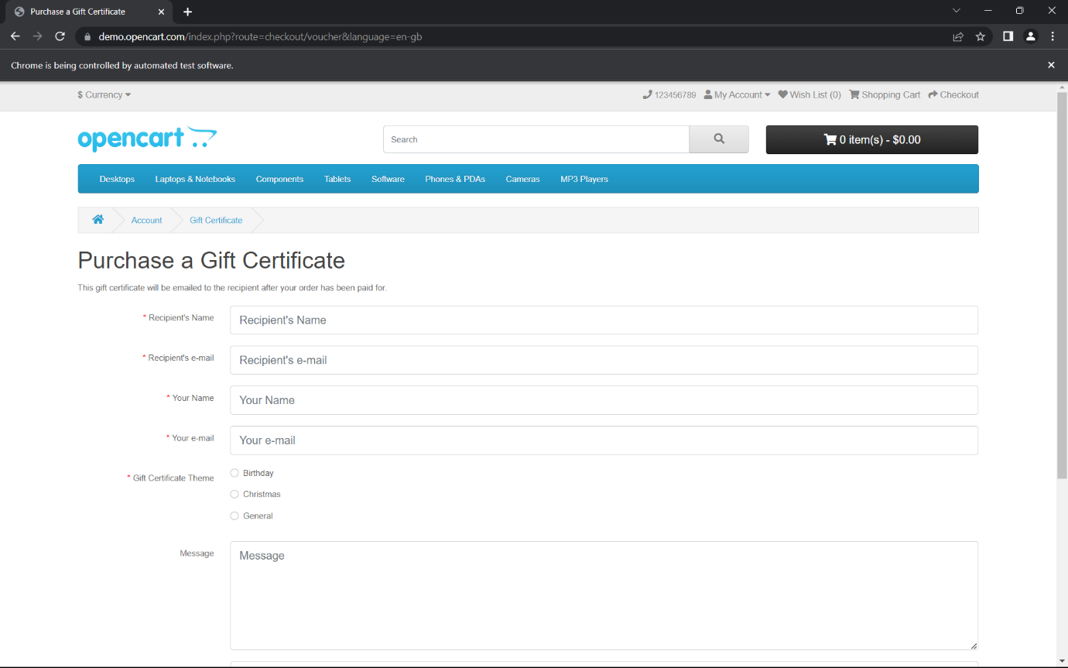

D4E4:

package D4;

import org.openqa.selenium.By;

import org.openqa.selenium.JavascriptExecutor;

import org.openqa.selenium.WebDriver;

import org.openqa.selenium.WebElement;

import org.openqa.selenium.chrome.ChromeDriver;

import org.openqa.selenium.chrome.ChromeOptions;

public class D4E4 {

public static void main(String[] args) throws InterruptedException

{

System.setProperty("webdriver.chrome.driver","C:\\ChromeDriver\\chromedriver.exe");

ChromeOptions co = new ChromeOptions();

co.addArguments("--remote-allow-origins=*");

WebDriver driver = new ChromeDriver(co);

driver.get("https://j2store.net/free/");

driver.manage().window().maximize();

JavascriptExecutor js=(JavascriptExecutor)driver;

js.executeScript("window.scrollBy(0,1000)","");

WebElement clothing = driver.findElement(By.xpath("//*[@id=\"Mod112\"]/div/div/ul/li[1]/h4/a"));

clothing.click();

driver.manage().window().maximize();

driver.navigate().back();

driver.navigate().forward();

driver.navigate().refresh();

driver.close();

}

}

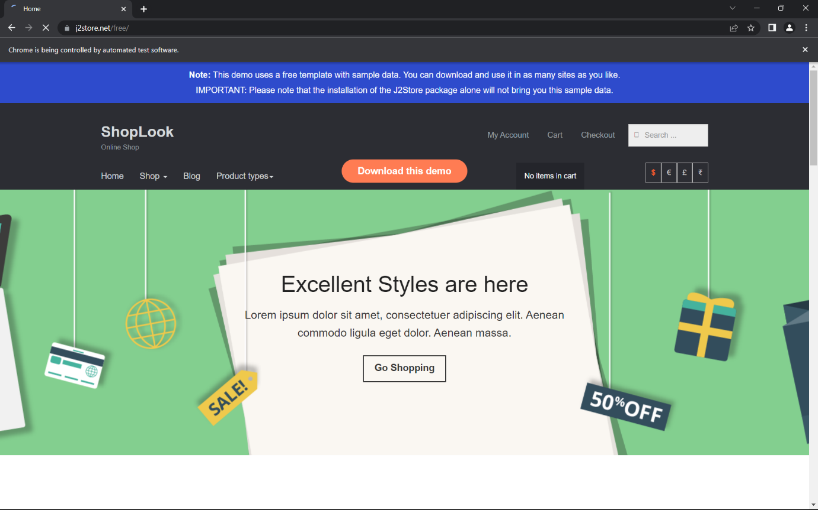

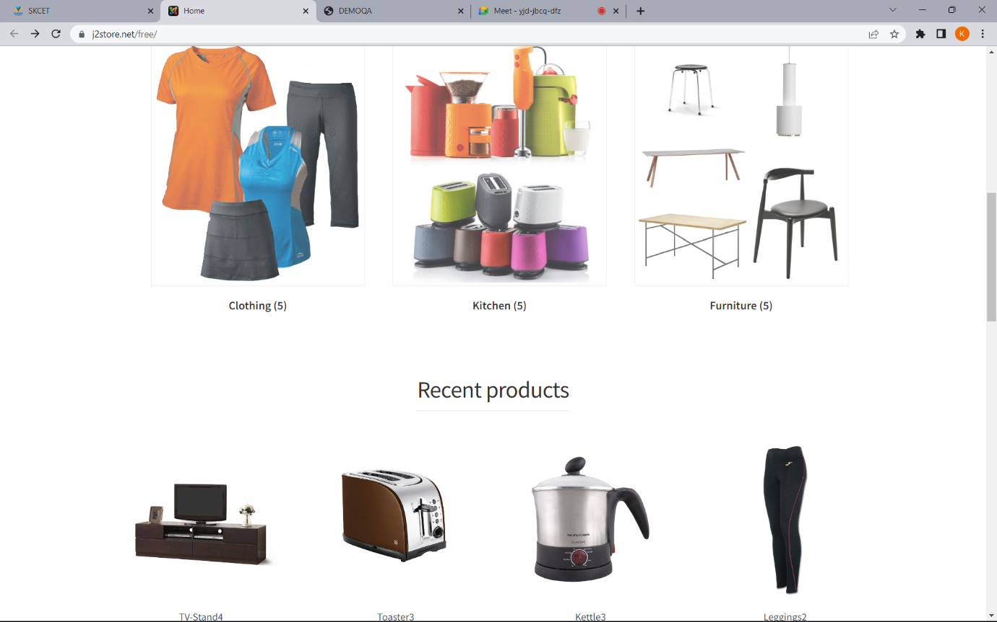

D4E5.1:

package day4;

import org.openqa.selenium.By;

import org.openqa.selenium.JavascriptExecutor;

import org.openqa.selenium.WebDriver;

import org.openqa.selenium.WebElement;

import org.openqa.selenium.chrome.ChromeDriver;

import org.openqa.selenium.chrome.ChromeOptions;

import io.github.bonigarcia.wdm.WebDriverManager;

public class D4E5 {

public static void main(String[] args)

{

WebDriverManager.chromedriver().setup();

ChromeOptions co = new ChromeOptions();

co.addArguments("--remote-allow-origins=*");

WebDriver driver = new ChromeDriver(co);

driver.get("https://j2store.net/free/");

driver.manage().window().maximize();

String url1 = driver.getCurrentUrl();

if(url1.equals("https://j2store.net/free/"))

{

System.out.println("url validated");

}

JavascriptExecutor js=(JavascriptExecutor)driver;

js.executeScript("window.scrollBy(0,1000)","");

WebElement clothing = driver.findElement(By.xpath("//*[@id=\"Mod112\"]/div/div/ul/li[1]/h4/a"));

clothing.click();

url1 = driver.getCurrentUrl();

if(url1.equals("https://j2store.net/free/index.php/shop?filter_catid=11"))

{

System.out.println("url validated");

}

}

}

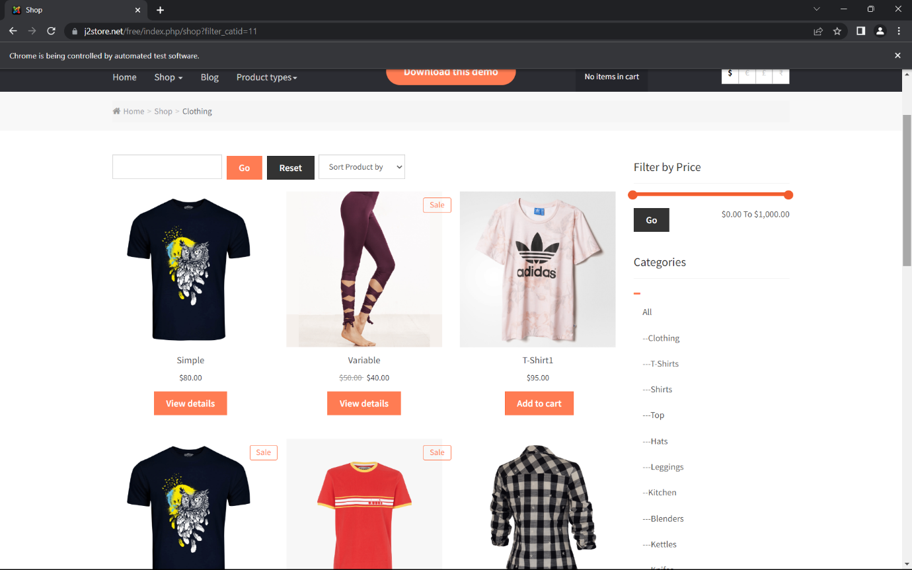

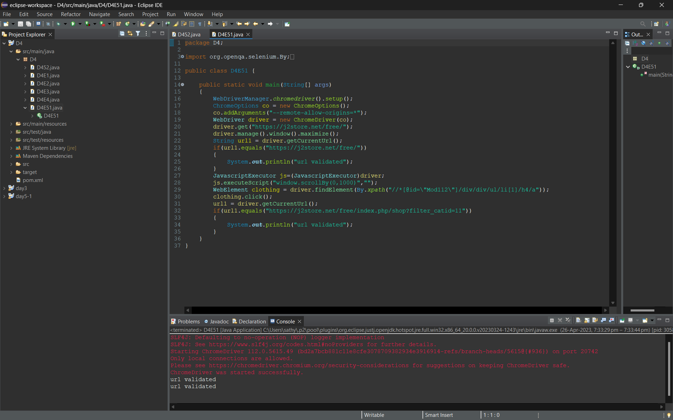

D4E5.2:

package day4;

import java.util.List;

import org.openqa.selenium.By;

import org.openqa.selenium.JavascriptExecutor;

import org.openqa.selenium.WebDriver;

import org.openqa.selenium.WebElement;

import org.openqa.selenium.chrome.ChromeDriver;

import org.openqa.selenium.chrome.ChromeOptions;

import io.github.bonigarcia.wdm.WebDriverManager;

public class D4E5II {

public static void main(String[] args) throws InterruptedException

{

WebDriverManager.chromedriver().setup();

ChromeOptions co = new ChromeOptions();

co.addArguments("--remote-allow-origins=*");

WebDriver driver = new ChromeDriver(co);

driver.get("https://j2store.net/free/");

driver.manage().window().maximize();

JavascriptExecutor js=(JavascriptExecutor)driver;

js.executeScript("window.scrollBy(0,1000)","");

driver.findElement(By.linkText("Clothing (5)")).click();

Thread.sleep(5000);

List<WebElement> l1 = driver.findElements(By.xpath("//h2[@class='product-title']"));

for(WebElement link : l1)

{

System.out.println(link.getText());

}

}

}

